Websign Design Documentation

Purpose of the Web Site?

This website will make anyone discover art through a series of pictures that are managed by the defined users.

Intended Audience?

This website is mainly designed and created for a community of art-enthusiast. It will provide a space for all of these people to express themselves through a user-managed gallery. The site will be characterised by a clean and simple design to offer an easy understanding of its functionalities. That way, the viewers can appreciate more their time on the website.

How does it achieve the intended goal of the project?

To ensure that our users will be satisfied, we created the website in a way that he offers:

* A home page with a background picture and text;
* A gallery page in which you will be able to search different things, see the pictures, their description, their id;
* A login page for our members with an id text field, a password field and a button to login;
* An Add content page for our users with a form to enter an URL, a description and to submit;
* A Remove Content Page for our users with an ID for deletion and a submit button;

On each page, you will have a slider menu that helps you navigate each page of the website, the title of the website and a link that redirects you to different social Medias.

Layout

The welcome page is the Home page. On it, you will simply have a background picture with the title, the footer for social Medias, and a button to open the sliders which allows you to navigate to other pages. This model will be used for each and every pages with subtle changes (adding search bars, blurry backgrounds on other pages, changes of backgrounds pictures ...).

Color Palette

For this website, I wanted to keep it sober and simple. We will use three colours that matches the background picture theme. Everything text related is in White, then all the layout borders and bands are in black and all the buttons are in brown.

On every input area, we try to use transparent backgrounds, no borders and a brown outline.

Layout

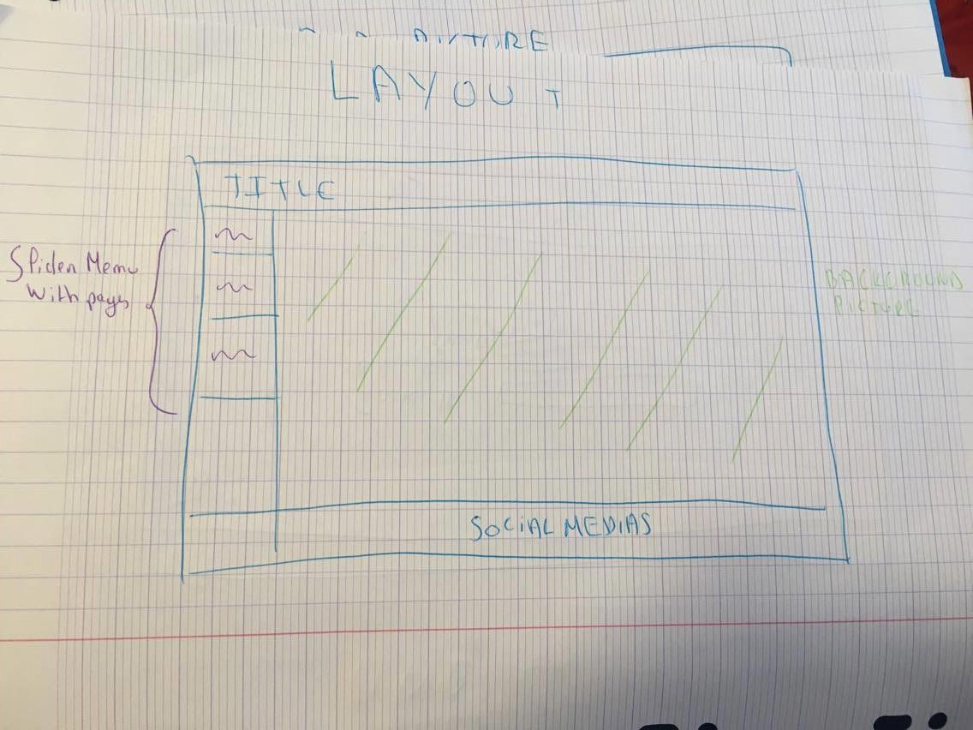

Login Page

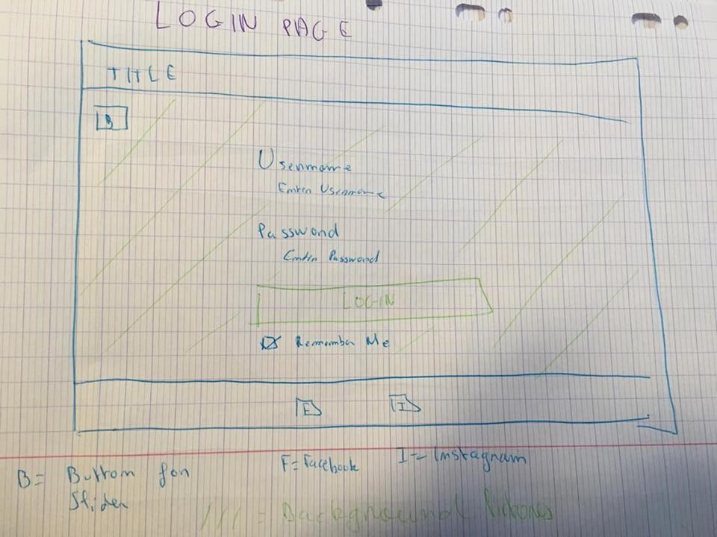

Pictures

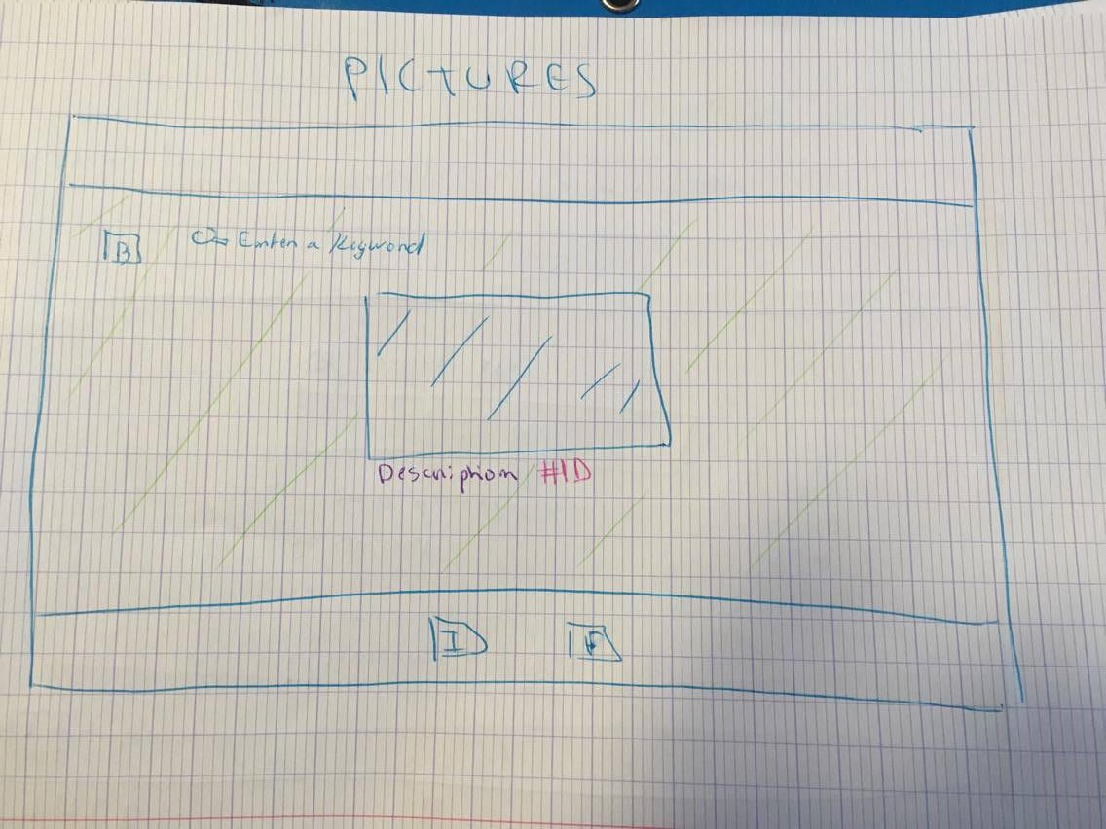

Add Picture

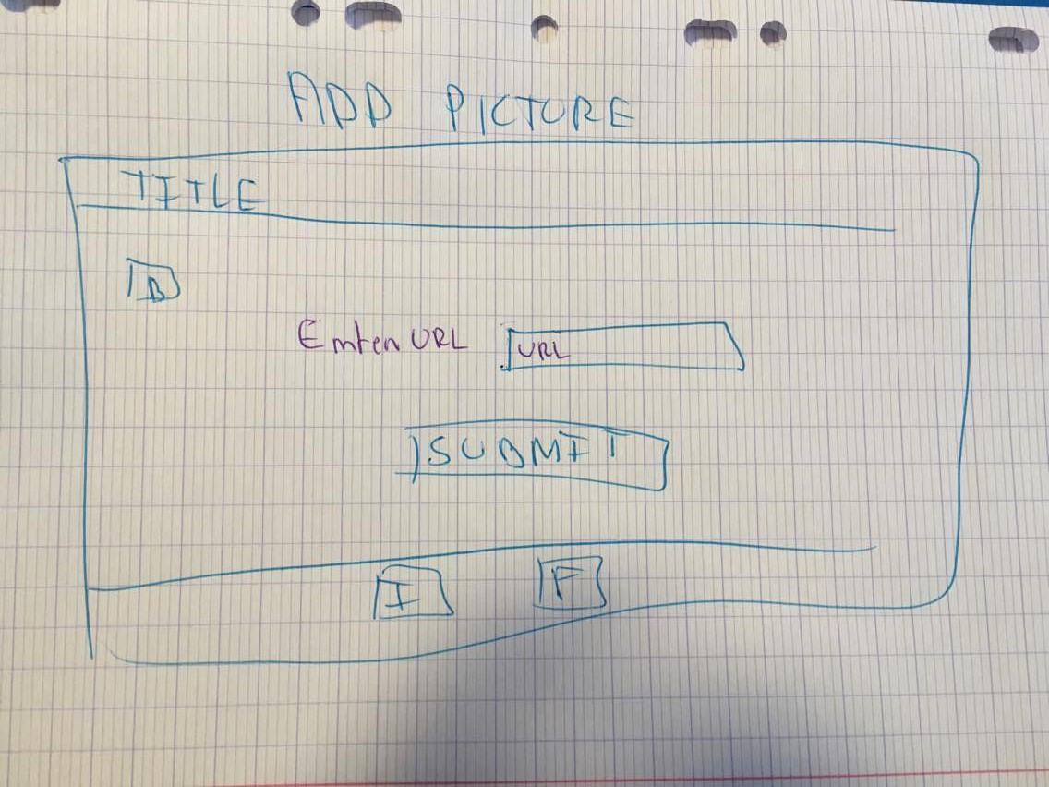

Remove Pictures

